Insert

Objective
Write the MongoDB command to insert a new Podcast document.

Query:-
db.podcasts.insertOne({
title: "Tech Talks Daily",
host: "Neil Patel",
duration_minutes: 75,
category: "Technology"})

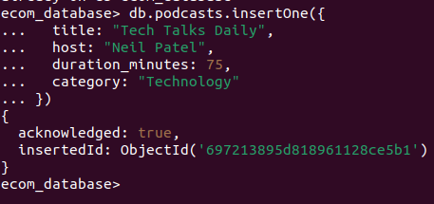

Explanation
- This command inserts a new podcast document into the podcasts collection in MongoDB.
- MongoDB stores data in flexible JSON-like format.

Find

Objective
Write a query to find all assets where Duration is greater than 60 minutes.

Query:-
db.podcasts.find({
duration_minutes: { $gt: 60 } })
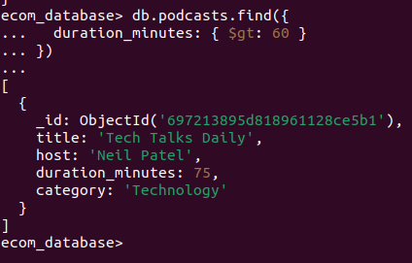

Explanation
- The $gt operator means greater than.
- This query retrieves all podcast documents where the duration exceeds 60 minutes.

Projection

Objective
Find all documents but return only the Title field and hide the _id field.

Query
db.podcasts.find(
{},
{ title: 1, _id: 0 }
)
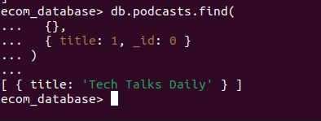

Explanation
- Projection controls which fields appear in the output.
- This query shows only the title field and hides the default _id field.

